

Group #6 - Deliverable 2

SYST28951 - System Development Methodologies

Guided under - Professor Harsh Thakkar

Date of Submission: Monday, October 12th, 2020

**Group Members:** Group Leader - *Steven Kebila (991569077), Vali Mohammad (991589723) , Arashdeep Singh (991590967), and Zawad Hossain (991853646)*

Table of Contents

|  |  |
| --- | --- |
| 1. Members Assigned Tasks | 2 |
| 1. Client Overview - NOVRS |  |
| 1. System Vision |  |
| 1. Context Diagram |  |
| 1. Use Case Diagram of the New System |  |
| 1. Intermediate Use Case Narratives |  |
| 1. Domain Class Diagram |  |

**Members Assigned Tasks**

This case study has been assigned as a group project with members consisting of four. Each group has a leader to guide us through the project. For our group we have elected **Steven** to be our “Group Leader” and we have assigned each member a task.

1. **Steven Kebila** (Group Leader) - Domain Class Diagram
2. **Vali Mohammad** - Context Diagram
3. **Arashdeep Singh** - Use Case
4. **Intermediate Use Case Narratives** - Entire group
5. **Zawad Hossain** - Documentation and Reporting

**Client Overview**

This case study is on Northern Ontario Recreational Vehicle Storage (NORVS) business venture renting out storage spaces to clients to stow away their recreational vehicles.

Owner/User : NORVS management

Client : People with recreational vehicles (ATV, boats, RVs, snowmobiles etc) who are willing to rent a place to store their vehicles during the off-season.

Till now this company, NORVS, has been manually operating that is without using any support of the technology. With time they are facing issues and challenges as more competitors enter the market. Inorder to give them a fight, NORVS management has decided to upgrade their system with the help of technology.

**System Vision**

This case study gives an overview of the existing system that NORVS is operating and the management’s vision of the new system.

* Challenges in Existing System

The business is designed to operate manually. First the clients need to call in to book a storage space for their vehicle. An employee records all the information as per client’s need with a payment for the storage. Then the client will drop off the vehicle at site. Clients get full flexibility to come and pick up their vehicle, but it is a flaw in the system. Based on the size of the vehicle the space is arranged by the staff and later if required to make space, they shift the vehicle to a different storage space across the premises. As the recording of information is done manually, due to lack of accountability, credibility or out of laziness, information is not written/update regularly for which the company management had to encounter embarrassing situations. At the end of the day a company will not be able to sustain if the accounts are not done properly, the management had complaints regarding record of the revenue. On top of that, arrival of new companies pose threat to the pioneer and inorder to survive the management decided to upgrade their system

* Addressing the issues in Proposed System

The new design for the system will be online-based fully-automated minimizing the human dependency factor. The new system will be supported by both mobile and desktop based web applications. The interested client will have to create a profile with all demographic, vehicle information and alongside biometric requirements which adds security as well as maintain the clients flexibility like in the old system by doing so management will also have a detailed record of the visitors. Once the profile is created the client will get updates online on space availability. Alongside the client profile, vehicle profile is also created with as much details possible to calculate the space needed and rental fee. After the client agrees, everything is documented and recorded at ease with the help of technology. Keeping flexibility in mind, the management will have the freedom to merge spaces to increase storage space and shift the vehicles from space to space, once moved the system will be updated and locating a vehicle will not be a problem. The system will also be integrated with an online popular third party payment to ensure secured transaction. Finally the reporting system will have two parts one is for the clients and another for the management which will have all the important information that is required. By implementing the system, it will ensure flexibility and ease for the clients with enhanced security(on-premises and payment) and will keep the confidence towards the owner company alive.

**Context Diagram**

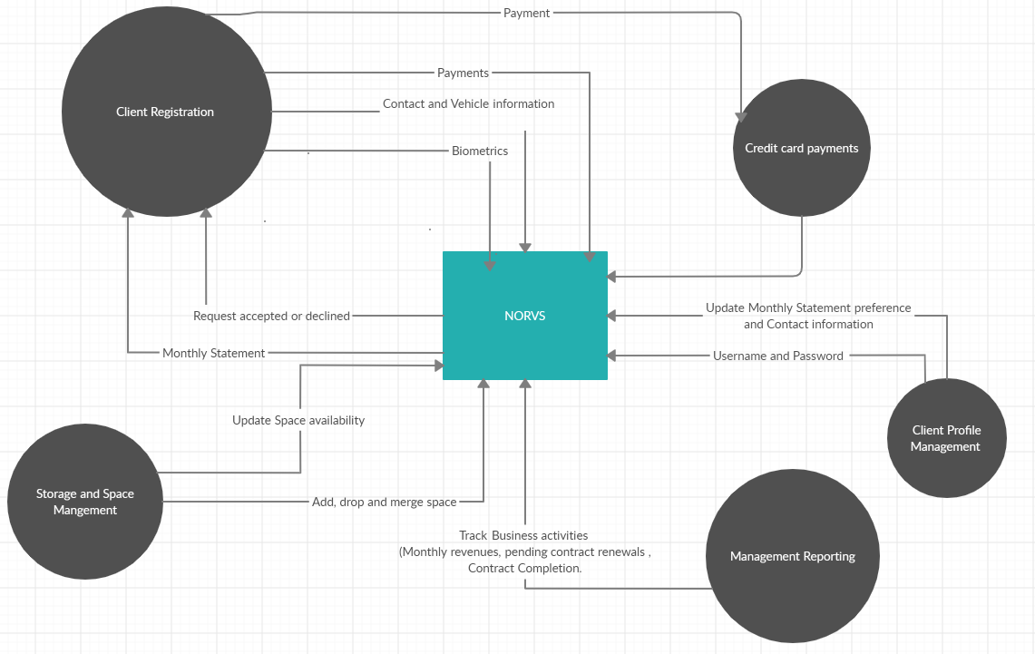

**Use Case Diagram**

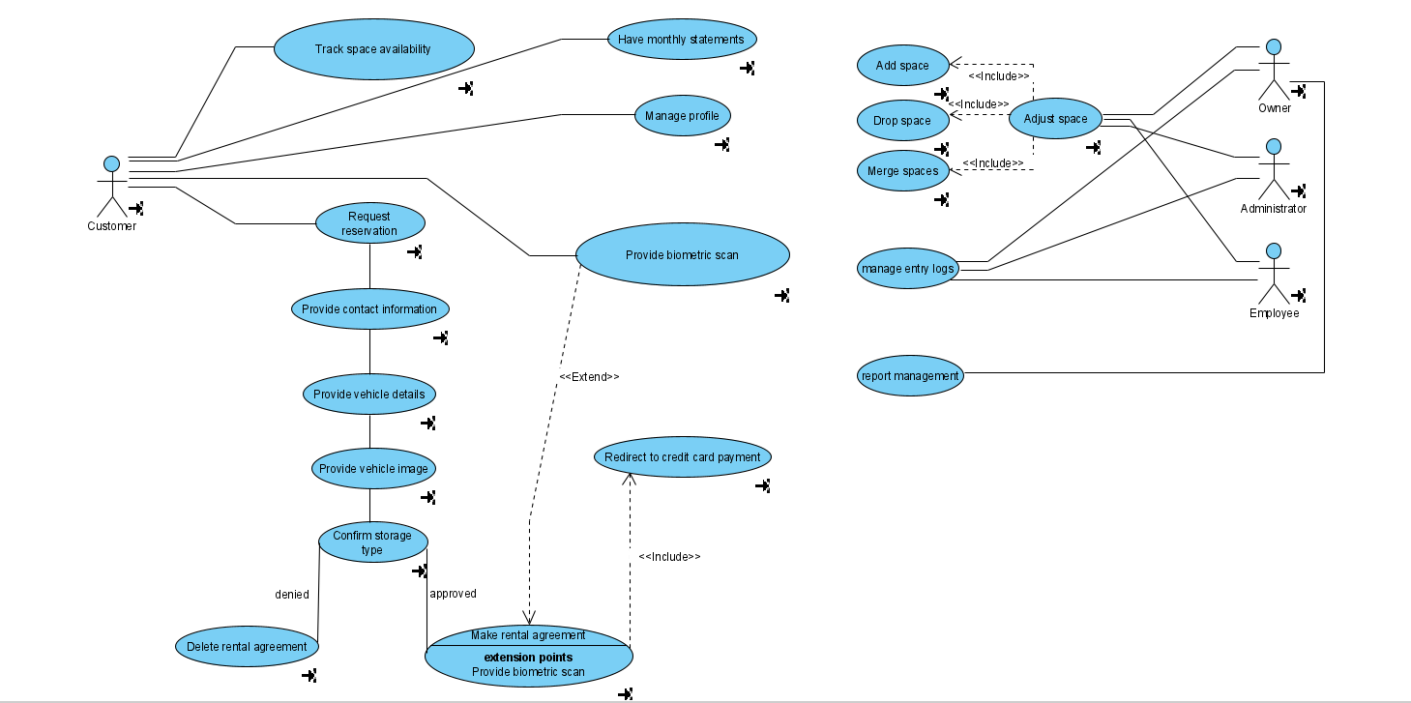

**Intermediate Use Case Narratives**

1. **Zawad Hossain**

|  |
| --- |
| Flow of activities for scenario of client arrives to pick up a vehicle |
| **Info**  Rank: Unspecified  ID: UC01  Status: Identity  Justification:  Primary Actor: Client  **Main Flow:**   1. Upon arrival to the premises, client scans for biometric ID 2. System check for a match 3. Upon a match. System    1. Updates the “Log of Entry”    2. Shares the location of the storage space to the client mobile application    3. Opens the gates 4. Client arrives at the rental space and enters the corresponding ID t0 access the space. 5. Upon a successful match, storage space is made accessible to the client. 6. Client takes the vehicle and exits the space. 7. Upon arrival at the premises exit, does the biometric scan. 8. After the scan, system    1. Updates the “Exit log”    2. Updates the availability of space    3. Opens the gate for the client to leave |
| **Exception Conditions**   1. Upon entering, if biometric scan fails, the system denies entry 2. If storage space ID does not match, its gate will not open and security will be notified |

|  |  |
| --- | --- |
| **Reason:** | Reason for choosing this user case flow, as I believe it is the main branch of this rental business, where clients are allowed to rent a space to keep their vehicles during off season. |

**2. Arashdeep Singh**

|  |
| --- |
| Flow of activities for scenario of client registering a storage space. |
| **Info**  Rank: Unspecified  ID: UC02  Status: Identity  Justification:  Primary Actor: Client  **Main Flow**  1. First, the client completes the reservation request.  2. Client provides their contact information.  3. Client provides their vehicle information. Which includes:-  4.1 Make  4.2 Color  4.3 Model  4.4 Year of manufacture  4.5 Approx. value  4. Client uploads a photo of his vehicle.  5. Client also provides width, height and length of the vehicle.  6. Client specifies the type of storage i.e. indoor or outdoor storage.  7. System checks for available space based on information provided.  8. If available, the system confirms the storage space.  9. Client also specifies the type of monthly statements i.e. hard or soft copy.  10. System approves the request and makes it a Rental Agreement. |
| **Exception Conditions**   1. If the system denies the request, no Rental Agreement is formed. |

|  |  |
| --- | --- |
| **Reason:** | My reason for choosing this use case flow is because this is the first step in the whole case study, without registration the client can’t move forward in the storage process. That is why I chose this use case flow. |

**3.** **Steven Kebila**

|  |
| --- |
| Flow of activities for scenario of Management(Owner, Employee) making Space Adjustment |
| **Info**  Rank: Unspecified  ID: UC06  Status: Identify  Justification:  Primary Actors: Administrator, Employee, Owner  **Main Flow**   |  | | --- | | 1. When a customer makes a commitment, Management (Owner, Employee)  can gain access to it | | 2. Management (Owner, Employee) signs in to the SYSTEM with their username  and password | | 3. Management checks for commitments made. | | 4. If commitments are made, management moves vehicle to appropriate space | | 4.1. Else if commitments are not made, managements logs out | | 5. If customer makes a commitment, Management will Add space | | 5.1. Else if customer cancels a commitment, Management will Drop space | | 5.2. Else if customer makes a commitment for 2 or more vehicles at a time,  Management will Merge Space | |  | |
| **Exception Conditions**   1. If no commitment is made, SYSTEM will display "No commitments made today" |

|  |  |
| --- | --- |
| **Reason:** | My reason for choosing this use case flow is because it is one of the main use cases that specifies how the storage room is managed by management. |

**4. VALI MOHAMMAD**

|  |
| --- |
| Flow of activities requesting the storage and paying the fee. |
| Rank: Unspecified  ID: UC05  Status: Identify  Justification:  Primary Actors: Client.  **Main Flow**   1. Client inquire for space. 2. Space not available agreement deleted. 3. Space available.   2. If space is available payment is requested from the client.  a. Payment unsuccessful client retry.  b. Payment successful.  3. Biometric scan would take place. After the biometric scan reservation is confirmed. |
| **Reason:** My reason for selecting this flow these are the very first steps for reserving storage. |

**Domain Class Diagram**

